**Name _____________________________**

**Homework 4**

**1.** Jonathan Hnosko (MS, Food Science, 2007) developed an experiment to measure the effects of pressure and time on the growth of Listeria, a food borne pathogen. The experiment consisted of two factors: Pressure at 3 levels (400, 450 and 500) and Time at 5 levels (1, 2, 3, 4 and 5 days post inoculation). A common source of Listeria was plated on 45 agarous petri dishes and were then randomized to the 15 combinations of Pressure and Time, such that each combination has three replicates. Thus, the design is a completely randomized design with a two-way treatment structure and three replicates per treatment combination. The log of the number of colony forming units (LogCFU) was recorded for each of the 45 petri dishes. The data for this experiment appear in the following table:

|  |  |  |  |  |  |  |
| --- | --- | --- | --- | --- | --- | --- |
|  |  | Time in Days | | | | |
|  |  | 1 | 2 | 3 | 4 | 5 |
| Pressure | 400 | 7.10, 7.29, 7.19 | 6.19, 5.86, 5.96 | 5.36, 4.89, 5.15 | 4.97, 4.66, 4.87 | 4.74, 3.36, 3.98 |
| 450 | 7.05, 8.10, 8.15 | 5.63, 5.16, 5.33 | 5.01, 4.99, 4.76 | 4.03, 3.03, 3.54 | 3.46, 2.15, 2.33 |
|  | 500 | 5.38, 4.78, 5.28 | 4.69, 4.38, 4.22 | 3.85, 3.21, 3.52 | 2.60, 1.54, 1.85 | 2.00, 1.80, 2.14 |

1. Use R or SAS to construct ANOVA table.
2. Perform necessary hypothesis tests using the traditional and p-value approach to hypothesis testing. Use a=.05.
3. Construct profile plot and interpret the plot.
4. Perform multiple comparisons using Tukey’s procedure if necessary.
5. Assess reasonableness of normality assumption using normal probability plot of residuals and Shapiro Wilk’s normality test.
6. Assess reasonableness of equal variance assumption using plot of residuals vs predicted values.

In the table below, order the cell means for Time, within each level of Pressure, from largest to smallest and then associate the letters A, B, C, etc. to indicate which means differ (grouping). Do the same for the second table, but this time order the cell means for Pressure, within each level of Time, from largest to smallest and then associate the letters to indicate which means differ.

|  |  |  |
| --- | --- | --- |
| Pressure Time | LSMeans | Grouping (Letter Assignment) |
| 1  2  400 3  4  5  1  2  450 3  4  5  1  2  500 3  4  5 |  |  |

5) continued

|  |  |  |
| --- | --- | --- |
| Time Pressure | LSMeans | Grouping (Letter Assignment) |
| 450  1 400  500  400  2 450  500  400  3 450  500  400  4 450  500  400  5 450  500 |  |  |

**SAS Code FOR QUESTION 1**

title "Analysis of Listeria Data - Completely Randomized Design";

title2 "with Two-Way Treatment Structure";

**data listeria;**

**input LogCFU Rep Pressure Time @@;**

**cards;**

**7.10 1 400 1 7.29 2 400 1 7.19 3 400 1**

**6.19 1 400 2 5.86 2 400 2 5.96 3 400 2**

**5.36 1 400 3 4.89 2 400 3 5.15 3 400 3**

**4.97 1 400 4 4.66 2 400 4 4.87 3 400 4**

**4.74 1 400 5 3.36 2 400 5 3.98 3 400 5**

**7.05 1 450 1 8.10 2 450 1 8.15 3 450 1**

**5.63 1 450 2 5.16 2 450 2 5.33 3 450 2**

**5.01 1 450 3 4.99 2 450 3 4.76 3 450 3**

**4.03 1 450 4 3.03 2 450 4 3.54 3 450 4**

**3.46 1 450 5 2.15 2 450 5 2.33 3 450 5**

**5.38 1 500 1 4.78 2 500 1 5.28 3 500 1**

**4.69 1 500 2 4.38 2 500 2 4.22 3 500 2**

**3.85 1 500 3 3.21 2 500 3 3.52 3 500 3**

**2.60 1 500 4 1.54 2 500 4 1.85 3 500 4**

**2.00 1 500 5 1.80 2 500 5 2.14 3 500 5**

**;**

**Proc print data = listeria;**

**run;**

**Proc glm data = listeria;**

**Class Pressure Time;**

**Model LogCFU = Pressure Time Pressure*Time;**

**output out = diagnostics r=residual p=predicted;**

**lsmeans Pressure*Time / adjust=tukey pdiff lines cl;**

**run;**

**Proc Univariate data = diagnostics normal plot;**

**var residual;**

**proc plot;**

**plot residual*predicted;**

**run;**

**2.** A company was interested in comparing three different display panels for use by air traffic controllers. Each display panel was to be examined under five different simulated emergency conditions. Thirty highly trained air traffic controllers with similar work experience were enlisted for the study. A random assignment of controllers to display-panel-emergency conditions was made, with two controllers assigned to each factor-level combination. The time (in seconds) required to stabilize the emergency situation was recorded for each controller at a panel-emergency condition. These data appear below.

Emergency Condition

|  |  |  |  |  |  |
| --- | --- | --- | --- | --- | --- |
| Display Panel | 1 | 2 | 3 | 4 | 5 |
| 1 | 18 16 | 31 35 | 22 27 | 39 36 | 15 12 |
| 2 | 13 15 | 33 30 | 24 21 | 35 38 | 10 16 |
| 3 | 24 28 | 42 46 | 40 37 | 52 57 | 28 24 |

1. Construct, by hand, the entire ANOVA table for this analysis. Please see example 14.6 on page 816 in your textbook or the document titled ‘Two-Factor Analysis of Variance Part 3’ in the modules area in Canvas. Also, use R or SAS to construct ANOVA table.

1. Perform necessary hypothesis tests using the traditional and p-value approach to hypothesis testing. Use a=.05.
2. Construct profile plot and interpret the plot.

1. Perform multiple comparisons using Tukey’s procedure if necessary.

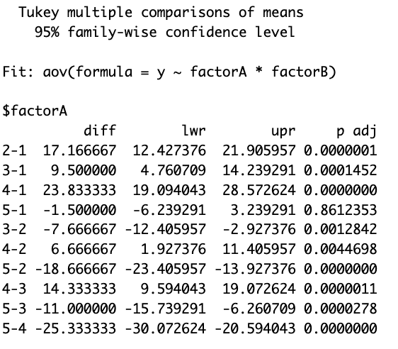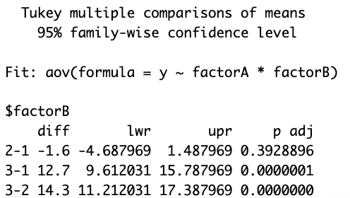

1. Assess reasonableness of normality assumption using normal probability plot of residuals and Shapiro Wilk’s normality test.

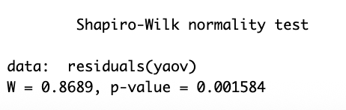

1. Assess reasonableness of equal variance assumption using plot of residuals vs predicted values.

